Web Technologies
How to create one complete application:
In order to create or develop a complete application we need 3 phases. They are:
1. Frontend
2. Middleware
3. Backend

Frontend:
- HTML
- CSS
- JavaScript
- React
- Angular
- Vue.js

Middleware
1. Java (Core, J2EE)
2. Python (Core, Advanced)

Backend
1. SQL
2. MySQL
3. PL/SQL
MERN – MongoDB, Express, React, Node
MEAN – MongoDB, Express, Angular, Node
MongoDB – Backend
Express, Node – Middleware
React, Angular – Frontend

How web works?
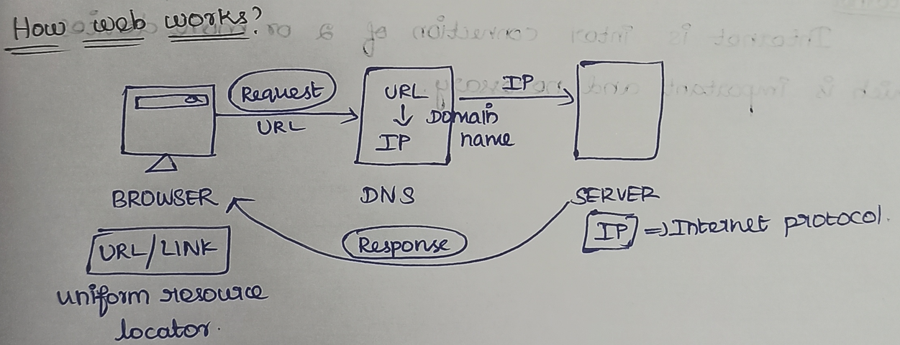
Browser sends Request(URL) -> DNS converts Domain Name(URL) to IP -> Server -> Response back to Browser.
Example URL: https://www.youtube.com
- https called protocal
- www called sub domain
- youtube called domain name
- com called top-level domain

URL = Uniform Resource Locator
HTTPS = HyperText Transfer Protocol Secure
DNS = Domain Name System
IP = Internet Protocol
WWW = World Wide Web
- Initially we will have a server and a browser, where the server understands IP and the browser understands URL/Link.
- Now from the browser sends a request in the form of URL/Link. Which will not go server directly as server understand IP.
- Now we have DNS (Domain Name System) as a translator in the middle which converts URL/link to IP by taking reference from the Domain Name.
- As a result after converting link/URL to the IP, DNS will send the IP to the server which is understandable by the server.
- As a result, finally server will send a response back to the browser.
- This is how internally web works.

Internet:
- Internet is the interconnection of two or more devices which is important and necessary.

Difference between LAN and WAN:
LAN | WAN
1. LAN stands for Local Area Network | 1. WAN stands for Wide Area Network
2. Ownership is private | 2. Ownership is public
3. Internet Speed is fast | 3. Internet Speed is less
4. The Internet Speed of LAN is 1000 Mbps | 4. The Internet Speed of WAN is 255 Mbps
5. Maintenance is easy and less expensive | 5. Maintenance is difficult and more expensive
6. Example: Wi-Fi | 6. Example: ISP - Internet Service Provider (Jio, Airtel)

Difference between Website, Webpage, Web Application
Webpage:
A webpage is a file or document written using HTML language.
Website:
A website is a collection or combination of multiple webpages.
Among these, a website takes more time to create or develop.
Web Application:
A web application is similar to a website, but users can interact and modify data.

